CSA1701-ARTIFICIAL INTELLIGENCE

NAME:A . Sri ram krishna
REG NO:192465011
TSP PROBLEM
Aim:
To write a Python program to solve the Travelling Salesman Problem (TSP) using the brute-force method.
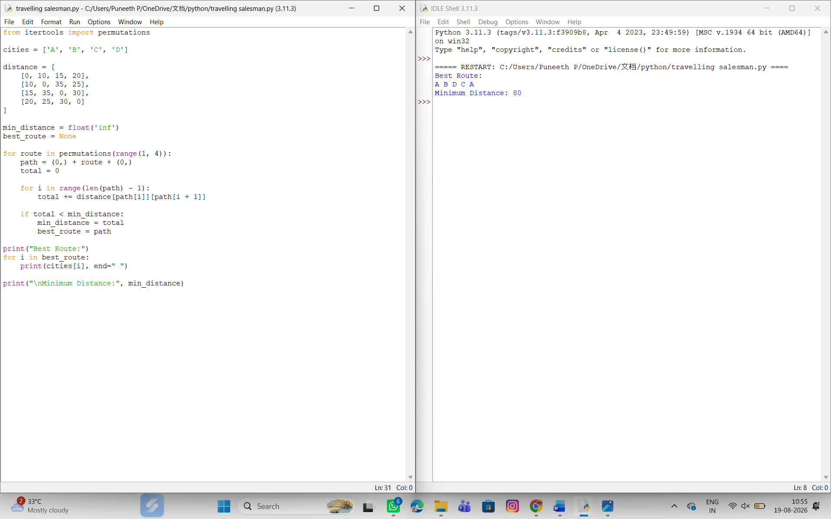

Result:
Thus, the Travelling Salesman Problem was successfully implemented using Python, and the minimum-cost route was found..

